Water Jug Problem
Aim
To solve the Water Jug Problem using Python by finding the sequence of steps to obtain the required amount of water.
Algorithm
- Initialize two jugs with capacities m and n.
- Fill one of the jugs.
- Pour water from one jug to the other until one becomes empty or the other becomes full.
- Empty a jug whenever necessary.
- Repeat the process until the desired quantity is obtained.
Python Code
from collections import deque

def water_jug(jug1, jug2, target):
visited = set()
queue = deque([(0, 0)])

while queue:
x, y = queue.popleft()

if (x, y) in visited:
continue
visited.add((x, y))

print((x, y))

if x == target or y == target:
print("\nTarget reached!")
return

next_states = [
(jug1, y), # Fill Jug1
(x, jug2), # Fill Jug2
(0, y), # Empty Jug1
(x, 0), # Empty Jug2
(max(0, x-(jug2-y)), min(jug2, y+x)), # Pour Jug1 -> Jug2
(min(jug1, x+y), max(0, y-(jug1-x))) # Pour Jug2 -> Jug1
]

for state in next_states:
if state not in visited:
queue.append(state)

water_jug(4, 3, 2)
Output
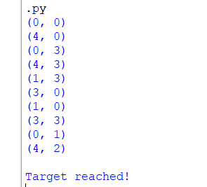
Result
The Water Jug Problem was successfully solved using Python. The program generated the sequence of valid states and reached the required target quantity of water successfully.

